HOMEWORK PIZZA NIGHT:
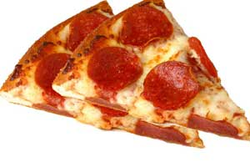
Dear Parents,
As of December, Zoll Studio is making art homework fun and more challenging!!!! Starting December 5th, Friday nights will be 3 hours long, from 4pm to 7pm. 2 hours and 45 minutes will be dedicated to homework and the last 15 minutes will be dedicated to pizza, friends and critique. Student should come prepared to work on any of their art homework assignments. Bring a sketchbook and/or 18X24 inch drawing pad. Mrs. Elicia has the rest of the supplies needed, unless your child needs something unusual for class.
Since this is a 3-hour class, the cost will be $45 per class by cash or check. Plus, your child will need an additional $10 in cash for the delivery of the pizza, the tip for the pizza guy, soda, cups, plates and napkins. You will be expected to pay $45 dollars at the beginning of each class and have the $10 in cash as well, for pizza. Paying one class at a time allows parents and children the freedom to come whenever convenient.
****Please text 24 hours ahead, with your child name, to let Mrs. Elicia know that you plan to join “pizza homework night.” *****

Thanks,
Elicia Frazier
Text at: 443-878-4574 (by Thursday night)

